Lemon and Baking soda Miraculous combination: 10, 000 times stronger than Chemotherapy!?
by Drew Canole, 2014

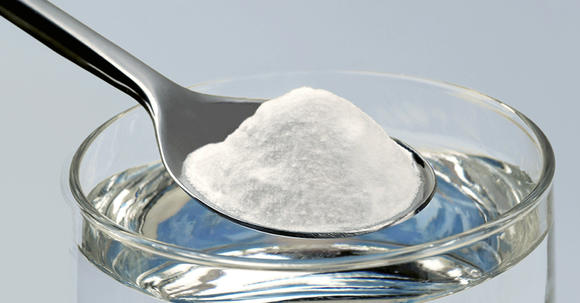

This is in not intended to be a replacement for something your doctor would advise. Always consult your physician.
Why do we not know about this?
Because there are organizations that continue to profit from disease. It is that simple.
Do you know how many people die while this secret is kept simply in the name of profit?
Lemon has already been proven to have strong anti – carcinogenic properties. In addition to this there are many other useful properties. Lemon has a strong effect on cysts and tumors.
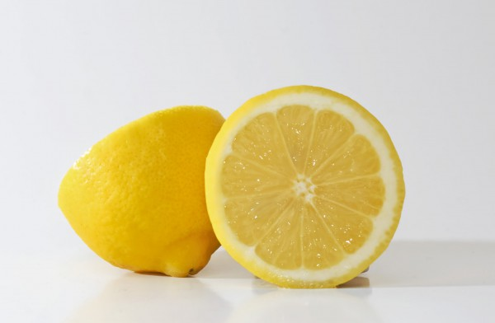
Citrus fruit can cure cancer. Recent studies have shown that consuming citrus fruits, specifically lemons have prevented and in some cases cured cancer. And by adding baking soda you will normalize the pH of the body which does not allow the cancer to continue to spread.
A recent case-control study out of Europe showed that consuming four or more 150-gram portions per week of citrus fruit decreased the risks of throat cancer by 58 percent, oral/pharyngeal cancer by 53 percent, stomach cancer by 31 percent, and colorectal cancer by 18 percent. This study did not find a protective effect of citrus against breast cancer, but a recent American study did show that women consuming about 75 grams daily of grapefruit (fruit or juice) saw a 22% reduction in breast cancer risk if they had never used hormone replacement therapy. It is noteworthy that the protective level of citrus consumption was nearly identical in both these studies (525-600 grams per week) and could be interpreted as a minimum intake level for meaningful cancer protection. However, it’s also important to know the best sources of limonoids if they are key to citrus fruit’s anti-cancer properties.
Lemon has a very strong antimicrobial effect with a very broad spectrum of activity against bacterial andfungal infections. Lemon is effective against internal parasites and worms, it regulates blood pressure and is a powerful antidepressant, reduces stress and nerve crises.

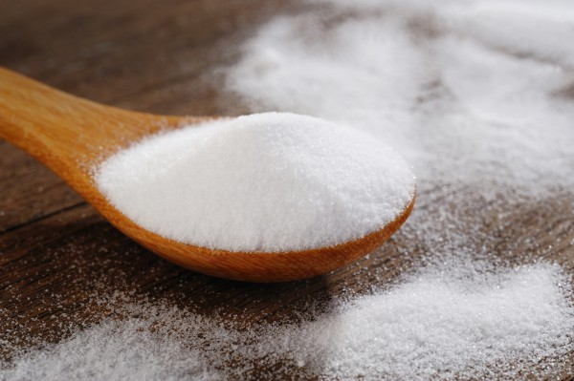
What is the source of this information? It comes from one of the largest manufacturers of drugs, which states that after 20 laboratory tests conducted since 1970 they have proved that:
Lemon destroys carcinogenic cells in 12 types of cancers. Lemon prevents the spread of carcinogenic cells and has 10,000 times stronger effect then drugs like Adriamycin, chemotherapy and narcotic products.

Chemotherapy has horrible side effects the worst being that it destroys healthy cells, simply put it kills you. Lemon juice and baking soda, on the other hand only kills the cancer cells.
Lemon and Baking soda Miraculous combination: 10, 000 times stronger than Chemotherapy!

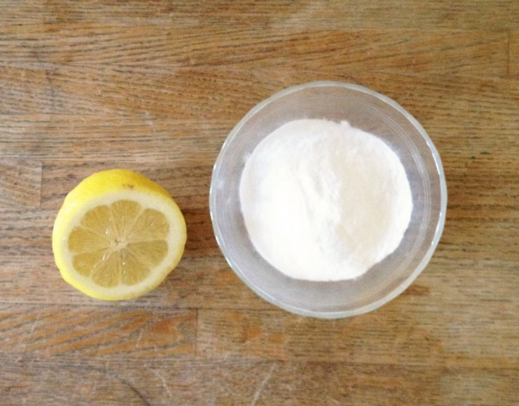

Ingredients
- lemon juice (1/2 lemon -- fresh squeezed)
- 1/4-1/2 teaspoon baking soda (no aluminum) Bob’s Redmill is a good source for Baking Soda without aluminum
- 4-8 oz water or juice (pomegranate or grape juice)
Drink this mixture prior to each mealtime.

Source:
Instituto de Ciencias de la Salud, L. L. C. 819 N. Charles Street Baltimore, MD 1201
http://www.secretlyhealthy.com/lemon-and-baking-soda-miraculous-combination/
http://cancerres.aacrjournals.org/content/69/6/2260.abstract
- See more at: http://fitlife.tv/lemon-and-baking-soda-miraculous-combination-10-000-times-stronger-than-chemotherapy/#sthash.JtdVTmDR.PC9KV85X.dpuf

